AI + Blockchain -Powered Heart Risk Prediction System

***Blockchain Lab Mini Project Report submitted in partial fulfillment. of the requirement for the degree of***

### B. E. (Information Technology)

Submitted By

|  |  |
| --- | --- |
| **21101A0008** | **Aryan Sawant** |
| **21101A0011** | **Ashish Verma** |
| **21101A0019** | **Vishal Devkate** |
| **21101A0017** | **Shivraj Pawar** |

Under the Guidance of Prof. Vinita Bhandiwad

Department of Information Technology



Vidyalankar Institute of Technology Wadala(E), Mumbai 400037 University of Mumbai

2024-25

Page1

CERTIFICATE OF APPROVAL

### For

**Mini Project Report On**

***Blockchain Lab Mini Project***

This is to Certify that

|  |
| --- |
| **Aryan Sawant** |
| **Ashish Verma** |
| **Vishal Devkate** |
| **Shivraj Pawar** |

Have successfully conducted Mini Project entitled.

### “AI + Blockchain-Powered Heart Risk Prediction System”

In partial fulfillment of degree course in Information Technology

As laid down by University of Mumbai during the academic year 2024-25

Under the Guidance of

### Prof. Vinita Bhandiwad

Signature of Guide Head of Department

Page2

Examiner 1 Examiner 2

# ACKNOWLEGEMENT

We would like to express our deepest appreciation to all those who provided us the possibility to complete this report. We express our profound gratitude we give to our **Prof. Vinita Bhandiwad** Ma’am, our respectable project guide, for her gigantic support and guidance. Without her counseling our project would not have understood something clearly at last of the day.

We extend our sincere thanks to **Dr. Vidya Chitre,** Head of the Department of Information Technology for offering valuable advice at every stage of this undertaking.

We would like to thank all the staff members who willingly helped us. We are grateful to **Vidyalankar Institute of Technology** for giving us this opportunity.

The days we have spent in the institute will always be remembered and be reckoned as guiding in our career.

Page3

|  |
| --- |
| **1. Aryan Sawant** |
| **2. Ashish Verma** |
| **3. Vishal Devkate** |
| **4. Shivraj Pawar** |

**Table of Contents**

Page4

|  |  |  |
| --- | --- | --- |
| **Sr.**  **No.** | **Table** | **Page No.** |
| 1. | Introduction | 06 |
| 2. | Aim & Objectives | 07 |
| 3. | Problem Definition | 08 |
| 4. | Proposed System   * Architecture/Framework * Algorithm and Process Design * Flow Diagram * Hardware & Software Requirements. | 09 - 10 |
| 5. | Results | 11 - 12 |
| 6. | Conclusion & Future Scope | 13 |
| 7. | References | 14 |
| 8. | GitHub Link | 14 |

**List of Figure**

Page5

|  |  |  |
| --- | --- | --- |
| **Sr. No** | **Figure** | **Page No.** |
| **1.** | **Flowchart** | **10** |
| **2.** | **User Inputs Data** | **11** |
| **3.** | **Prediction and Health Advice** | **11** |
| **4.** | **Store on Blockchain** | **11** |
| **5.** | **Past Predictions** | **12** |
| **6.** | **Past Trend Charts** | **12** |

**Introduction**

Page6

Cardiovascular diseases (CVDs) are a leading cause of mortality worldwide, and early detection plays a crucial role in preventing severe health complications. This project integrates **Artificial Intelligence** (AI), **Blockchain**, and **Generative AI** to develop a secure, transparent, and personalized heart risk prediction system.

Using Optimized Random Forest, the system predicts the likelihood of heart disease based on key health indicators. The results are securely stored on the Polygon PoS blockchain, ensuring data integrity and transparency. Additionally, **Google Gemini 2.0** Flash generates personalized health plans tailored to each user’s condition, providing dietary, exercise, and lifestyle recommendations.

By leveraging blockchain technology, this system ensures that users' medical data remains tamper-proof and accessible only to authorized individuals. The integration of smart contracts automates data storage and retrieval, enhancing trust and security in medical predictions. This decentralized approach not only prevents unauthorized data manipulation but also facilitates seamless sharing of records among healthcare providers.

Furthermore, the incorporation of interactive data visualization through **Streamlit** and **Plotly** enables users to monitor their health metrics in real time. The platform provides graphical representations of risk factors, historical trends, and prediction outcomes, making it easier for users to understand and take proactive steps toward better heart health. By combining AI-driven risk assessment, blockchain security, and generative AI-powered recommendations, this project aims to revolutionize preventive healthcare and empower users with actionable insights for a healthier life.

# Aim & Objectives

Page7

## Aim:

The aim of this project is to develop an **AI-powered heart risk prediction system** that leverages **machine learning (Optimized Random Forest), blockchain (Polygon PoS), and generative AI (Google Gemini 2.0 Flash)** to provide **accurate risk assessments, secure data storage, and personalized health recommendations**, ensuring transparency, security, and proactive healthcare management.

## Objectives:

**Heart Disease Risk Prediction** – Develop an AI model using **Optimized Random Forest** to accurately predict heart disease risk based on patient data.

**Secure Data Storage with Blockchain** – Implement **Polygon PoS** to securely store heart risk predictions on a decentralized network, ensuring data integrity and transparency.

**Generative AI for Personalized Health Plans** – Utilize **Google Gemini 2.0 Flash** to generate customized health recommendations based on risk predictions.

**Real-time Data Visualization** – Build an interactive dashboard using **Streamlit & Plotly** to analyze trends, visualize patient data, and provide insights into risk factors.

**API-based AI Model Deployment** – Deploy the machine learning model via a **Flask API**, enabling seamless integration with frontend applications.

**Smart Contract Integration** – Develop and deploy **Solidity-based smart contracts** using **Hardhat & Ethers.js** to securely record and verify predictions on the blockchain.

**Seamless User Interaction** – Enable easy access to risk predictions and health plans through **MetaMask & web3.py**, allowing users to retrieve their data securely.

**Real-Time Risk Monitoring** – Allow real-time monitoring of heart disease risk using continuous data updates and blockchain transactions, ensuring the latest information is accessible.

# Problem Definition

Page8

Cardiovascular diseases (CVDs) are a leading cause of mortality worldwide, often due to late diagnosis and inadequate preventive measures. Traditional heart disease risk assessment methods rely on periodic clinical checkups, which may not always provide real-time, data-driven insights. Additionally, storing medical records in centralized systems poses risks related to security, data integrity, and unauthorized access.

Additionally, **data security and privacy concerns** remain a major challenge in healthcare systems. Patient records stored in centralized databases are vulnerable to breaches, unauthorized access, and data manipulation. The lack of transparency in handling medical records can lead to trust issues between patients and healthcare providers. A **decentralized and tamper-proof system** is needed to ensure the security, integrity, and accessibility of medical data while maintaining patient confidentiality.

Furthermore, **existing heart disease prediction models often lack optimization**, leading to reduced accuracy in risk assessment. Many machine learning-based approaches do not incorporate advanced tuning techniques, resulting in suboptimal model performance. An optimized predictive model is crucial to improving diagnostic accuracy and providing reliable risk assessments.

To address these challenges, this project integrates **Artificial Intelligence (AI), Blockchain, and Generative AI** to develop a **secure, intelligent, and patient-centric healthcare solution**. The proposed system will:

1. **Use an optimized machine learning model** (Random Forest with Optuna optimization) to provide accurate heart disease risk predictions based on patient data.
2. **Leverage blockchain technology (Polygon PoS)** to ensure the secure and tamper-proof storage of prediction records, giving patients full control over their health data.
3. **Incorporate Generative AI (Google Gemini 2.0 Flash)** to generate personalized health plans, offering tailored recommendations for lifestyle modifications, diet, and exercise based on an individual’s risk profile.
4. **Provide an interactive visualization dashboard** (Streamlit & Plotly) to help patients and healthcare providers analyze trends, track progress, and make informed decisions.

By integrating these technologies, the project **aims to bridge the gap between AI-driven healthcare and blockchain security**, offering a robust, scalable, and privacy-preserving solution for heart disease risk assessment and prevention.

# Proposed System

Page9

The proposed system is an **AI-powered heart disease risk prediction platform** that integrates **Machine Learning, Blockchain, and Generative AI** to provide a **secure, intelligent, and personalized healthcare solution**. The system is designed to **accurately predict heart disease risks, store medical records securely using blockchain, and generate personalized health recommendations** to help individuals manage their heart health effectively.

### Architecture/Framework:

**System Architecture**

The system follows a **three-tier architecture**:

1. **Frontend (User Interface)** – Built with **Streamlit**, providing an interactive and user-friendly experience for patients and healthcare providers.
2. **Backend (AI Model & Blockchain Integration)** – Developed using **Flask**, handling AI predictions, blockchain transactions, and API interactions.
3. **Blockchain Layer** – Utilizes **Polygon PoS** for secure data storage with smart contracts written in **Solidity**, deployed using **Hardhat** and managed via **Ethers.js**.

**Frameworks & Technologies Used**

* **Machine Learning:** Scikit-learn, Optuna (Hyperparameter Optimization)
* **Generative AI:** Google Gemini 2.0 Flash (For personalized health plans)
* **Blockchain:** Solidity, Hardhat, Polygon PoS, Alchemy, MetaMask, Web3.py, Ethers.js
* **Data Visualization:** Streamlit, Plotly
* **Deployment & API Management:** Flask, dotenv

### Algorithm and Process Design:

1) **Heart Disease Prediction (Optimized Random Forest)**

* + Data preprocessing (handling missing values, normalization).
  + Feature selection (RFE, feature engineering).
  + Model training with **Optuna** for hyperparameter tuning.
  + Prediction evaluation (Accuracy, Precision, Recall, F1-score, ROC-AUC).
  + Deployment via Flask API.

2) **Blockchain Storage (Polygon PoS)**

* + Smart contract deployment in **Solidity**.
  + Secure storage of AI predictions on the blockchain.
  + MetaMask authentication for transaction execution.

3) **Generative AI for Personalized Health Plans (Google Gemini 2.0 Flash)**

* + AI processes patient data and heart risk factors.
  + Generates **personalized diet, exercise, and lifestyle plans**.
  + Interactive Streamlit dashboard for recommendations.

### Flowchart:

### 

### Fig.1. Flowchart

### Hardware & Software Requirements:

**Hardware:**

Page10

* **Computer/Server:** Runs blockchain network and smart contracts.
* **High-Speed Internet Connection:** Ensures smooth transaction processing.
* **Others**: MetaMask-compatible device, secure storage for blockchain keys

### Software:

#### **Blockchain Tools:**

* **Polygon PoS** – Scalable Ethereum Layer 2 solution for secure storage.
* **Solidity** – Smart contract programming language.
* **Hardhat** – Smart contract development and testing framework.
* **Ethers.js** – JavaScript library for blockchain interactions.
* **Alchemy** – Blockchain API provider for smart contract deployment.
* **MetaMask** – Ethereum wallet for transaction management.

#### **Development Environment:**

* **Flask** – Lightweight web framework for API deployment.
* **Scikit-learn** – Machine learning library for AI-based heart risk prediction.
* **Optuna** – Hyperparameter optimization for Random Forest model.

# Results

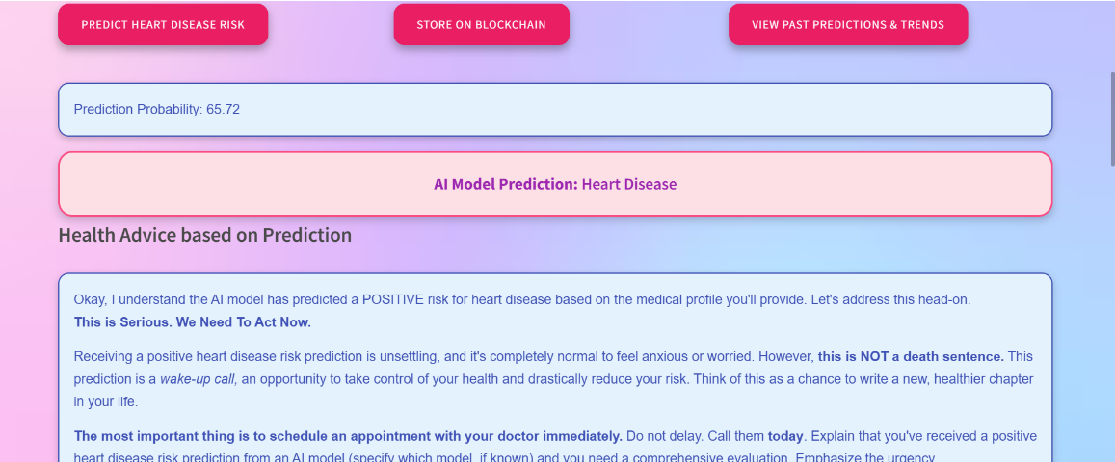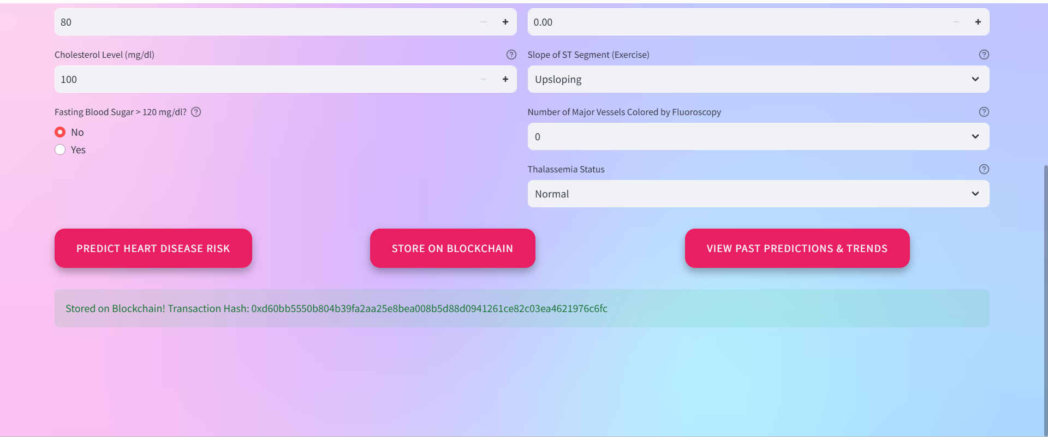

Page11

Fig.2. User Inputs Data

Fig.3. Prediction and Health Advice

Fig.4. Store On Blockchain

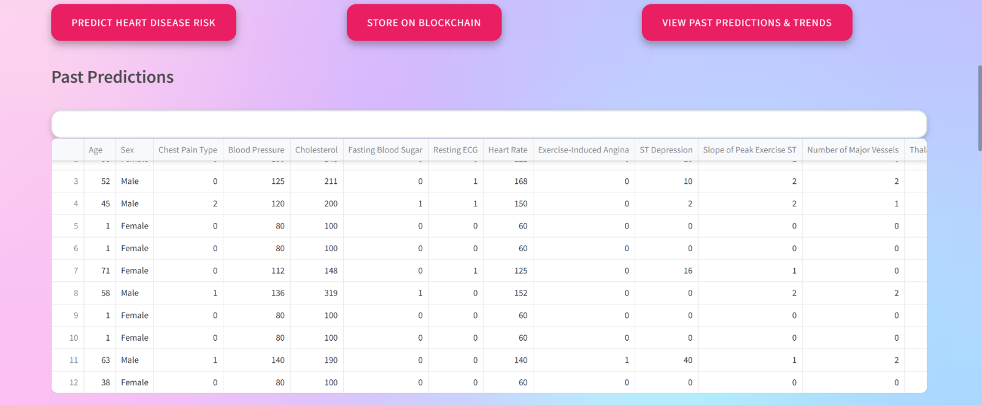

Page12

Fig.5. Past Predictions

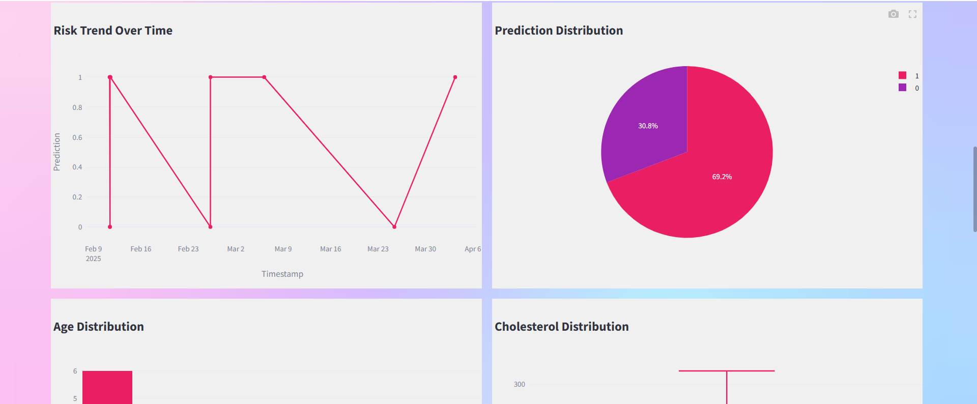

Fig.6. Bank asking Customer to view/modify KYC

Fig.6. Past Trend Charts

# Conclusion & Future Scope

Page13

### Conclusion:

This project integrates AI-driven heart disease risk prediction with blockchain for secure data storage and generative AI for personalized health plans. By leveraging machine learning, smart contracts, and interactive data visualization, it ensures accurate predictions, transparency, and accessibility. The system provides a secure, efficient, and user-friendly platform for proactive heart health management.

### Future Scope:

* **Enhanced AI Models:** Integration of more advanced deep learning techniques for improved prediction accuracy.
* **Multi-Chain Blockchain Support:** Expanding storage to multiple blockchain networks for better security and scalability.
* **Wearable Device Integration:** Real-time health monitoring by connecting with smartwatches and fitness trackers.
* **Personalized Treatment Plans:** AI-driven recommendations based on continuous health data analysis.
* **Mobile Application:** Development of a user-friendly mobile app for easy access to predictions and reports.
* **Global Healthcare Collaboration:** Secure data sharing with hospitals and research institutions for better healthcare insights.
* **Voice & Chatbot Assistance** – AI-powered health consultation via voice and text interactions.

The project demonstrates the potential of AI-powered heart risk prediction combined with blockchain for secure and transparent health record management. By leveraging machine learning for accurate risk assessment and blockchain for tamper-proof data storage, it ensures reliability and privacy in healthcare applications. With further advancements, including real-time monitoring, personalized health plans, and enhanced security measures, this system can revolutionize preventive healthcare, making heart disease prediction more accessible, efficient, and trustworthy.

# References:

Page14

* **Ethereum Documentation. (n.d.).** Ethereum Developer Resources. Retrieved from[**https://ethereum.org/en/developers/docs/**](https://ethereum.org/en/developers/docs/)
* **Web3.js Documentation. (n.d.).** Ethereum JavaScript API — web3.js 1.0.0 documentation. Retrieved from[**https://web3js.readthedocs.io/**](https://web3js.readthedocs.io/)
* **Google Gemini AI. (n.d.).** AI-Powered Healthcare Solutions. https://ai.google/discover/gemini
* **Optuna Framework. (n.d.).** An Open-source Hyperparameter Optimization Framework. [**https://optuna.org/**](https://optuna.org/)
* **Polygon PoS Blockchain. (n.d.).** Polygon Technology for Secure Storage. **https://polygon.technology/polygon-pos**
* **Ethers.js Documentation. (n.d.).** Ethereum Blockchain Interaction. **https://docs.ethers.org/v5/**
* **Streamlit Documentation. (n.d.).** Open-source App Framework for Machine Learning and Data Science. Retrieved from[**https://streamlit.io/**](https://streamlit.io/)
* **Plotly Data Visualization. (n.d.).** Interactive Graphing Libraries.[**https://plotly.com/**](https://plotly.com/)
* **Research on Blockchain-Based Healthcare Data Security. (n.d.).** IEEE Xplore.[**https://ieeexplore.ieee.org/document/8607002**](https://ieeexplore.ieee.org/document/8607002)
* **AI-Powered Predictive Healthcare Models. (n.d.). ResearchGate.** [**https://www.researchgate.net/publication/360123456_AI_Healthcare_Models**](https://www.researchgate.net/publication/360123456_AI_Healthcare_Models)

**GitHub Link: -** [**https://github.com/Aryan-sawant/AI-Blockchain-Powered-Heart-Risk-Prediction**](https://github.com/Aryan-sawant/AI-Blockchain-Powered-Heart-Risk-Prediction)